**Light intensity falloff with distance**

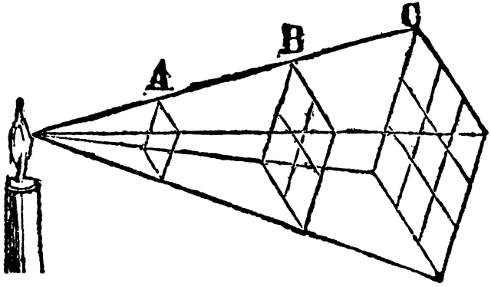



I = $\frac{constant}{distance{}^{2}}$ (distance = from light source)

**Properties of Intensity**

* As the the distance increases, the intensity gets smaller
* As the intensity gets bigger, the distance gets bigger
* Both of these are indirectly proportional

Scaling relation for I:

* = ()2 ← need this on card
* Make distance half and how does Intensity change
* d<final> = ½ distance <initial>
* Example two
* Start 12 meters from light. Change position so light 9 times less intense. Where are you?
* I <final> = 1/9 I